**Installation and Navigation of Visual Studio Code (VS Code)**

1. **Installation of visual Studio Code (VS Code)**

To download and install Visual Studio Code (VS Code) on Windows 11, follow these steps:

**Prerequisites:**

1. Internet Connection: Ensure your computer is connected to the internet.

2. System Requirements: Check that your computer meets the minimum system requirements for running VS Code.

**Steps to Download and Install Visual Studio Code**:

**1. Download VS Code Installer:**

- Open a web browser (like Edge or Chrome).

- Go to the official VS Code website: [https://code.visualstudio.com](https://code.visualstudio.com).

- Click on the "Download for Windows" button. This should automatically detect your operating system and start downloading the installer (either a `.exe` or `.zip` file).

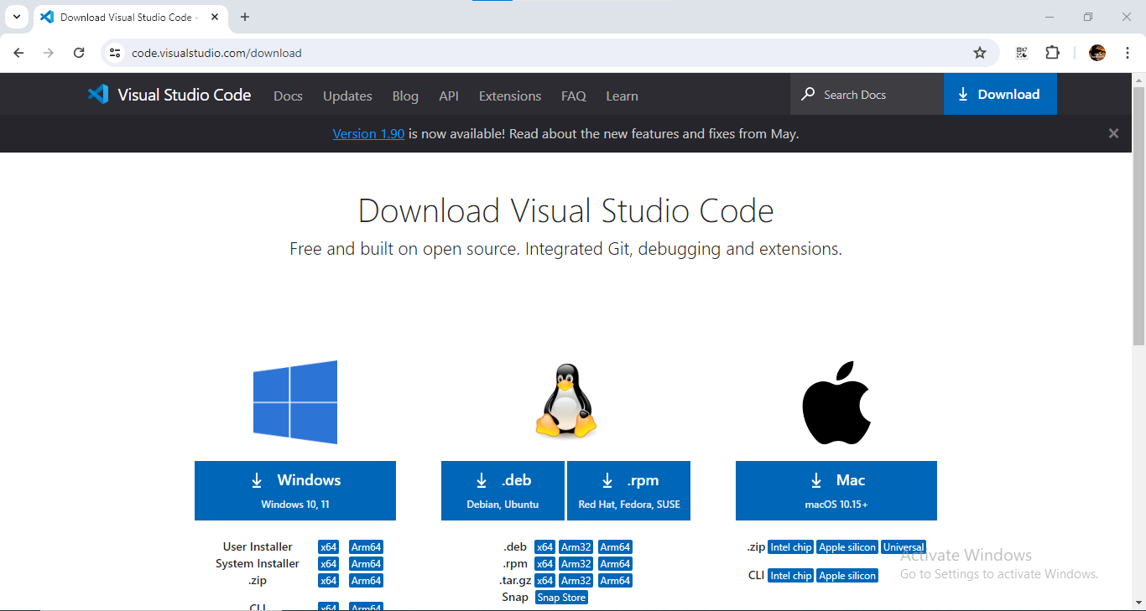

**2. Run the Installer:**

- Once the download completes, locate the downloaded installer file (typically in your Downloads folder).

- Double-click on the installer file to start the installation process.

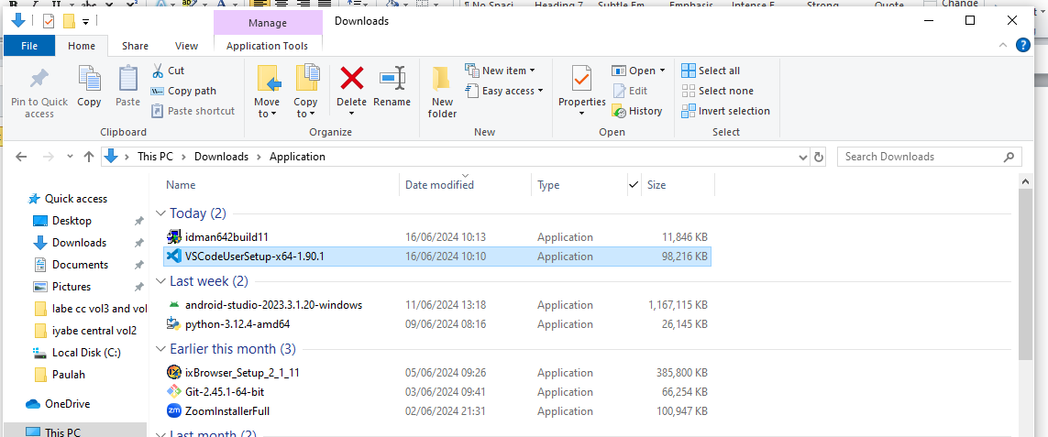

**3. Install VS Code:**

- The installer will guide you through the installation steps.

- You may be asked to confirm that you want to allow the installer to make changes to your device (User Account Control).

- Follow the on-screen instructions in the installer wizard (e.g., choosing the installation location, confirming installation settings).

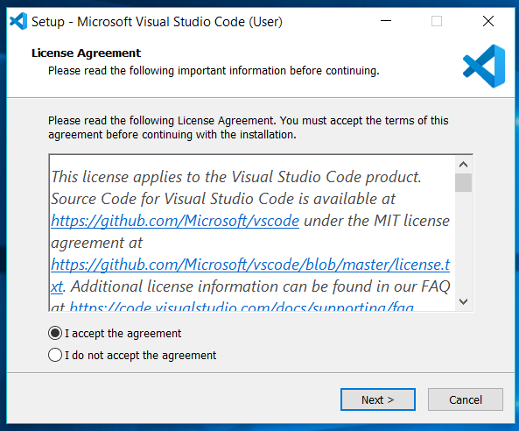

**4. Open Visual Studio Code:**

- After the installation completes, you can open VS Code by:

- Finding it in the Start menu under "Visual Studio Code".

- Double-clicking the desktop shortcut if you chose to create one during installation.

- Searching for "Visual Studio Code" in the Windows search bar.

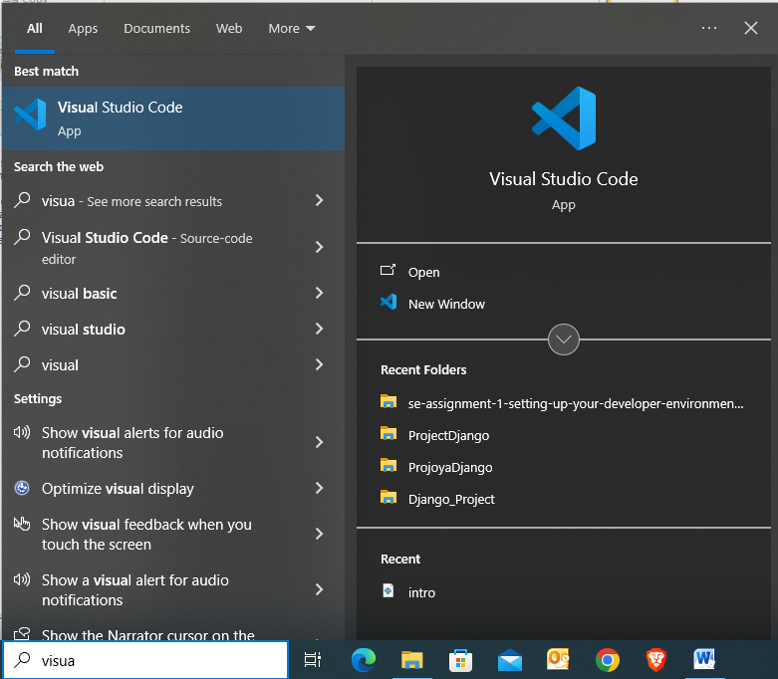

1. **First-time Setup:**

Setting up VS Code for an optimal coding environment involves configuring both basic settings and installing essential extensions. Here’s a comprehensive guide:

**Basic Settings:**

**1. Font and Theme:**

- Set your preferred font and font size under `Editor: Font Family` and `Editor: Font Size`.

- Choose a theme (`File > Preferences > Color Theme`) that you find comfortable.

**2. Tab Size and Indentation:**

- Adjust `Editor: Tab Size` and `Editor: Insert Spaces` (to control whether tabs are converted to spaces).

- Consider enabling `Editor: Render Whitespace` to visualize spaces and tabs.

**3. Automatic Save:**

- Optionally, enable `Files: Auto Save` to save files automatically after a delay or on window focus change.

**4. Workspace Settings:**

- Use workspace settings (`.vscode/settings.json`) for project-specific configurations.

**Recommended Extensions:**

**1. Language Support:**

- Programming Language Extensions: Install extensions specific to the programming languages you work with (e.g., Python, JavaScript, Java).

- Debugger Extensions: Install debugging extensions for your languages of choice (`Debugger for Chrome`, `Python`, etc.).

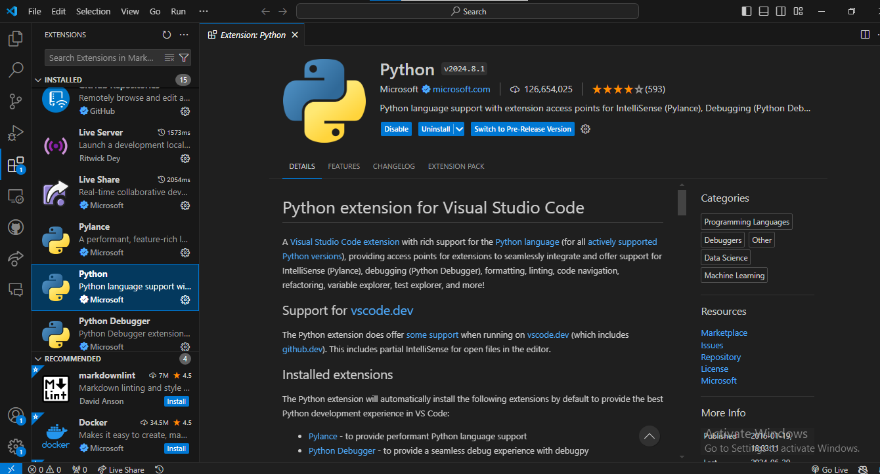

**2. Productivity Tools:**

- Git Integration: `GitLens` for advanced Git integration.

- Code Formatting: `Prettier` or `ESLint` for code formatting.

- Live Share: `Live Share` for collaborative coding sessions.

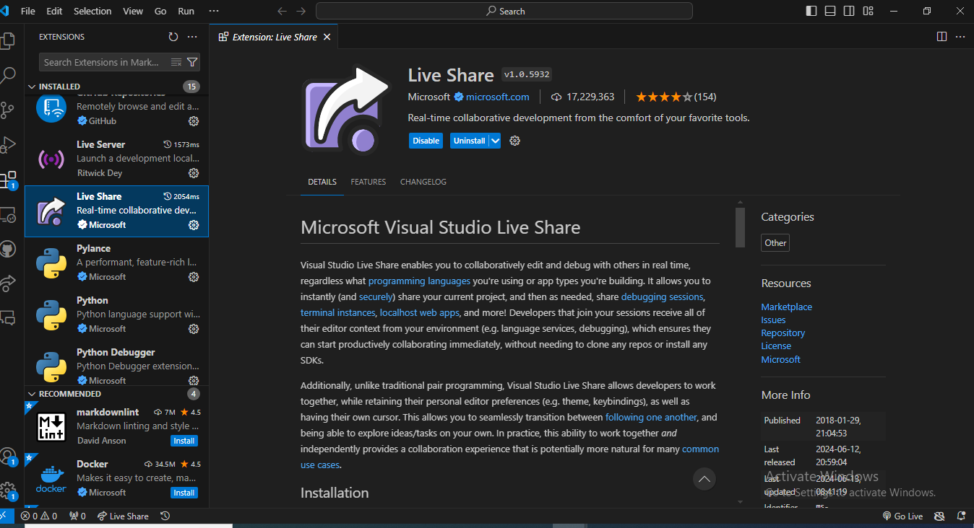

1. **User Interface Overview:**

Visual Studio Code (VS Code) has a user-friendly interface designed to enhance productivity and customization. Here are the main components of the VS Code user interface:

**1. Activity Bar:**

The Activity Bar is located vertically on the far left side of the VS Code window. It contains icons that provide quick access to different views and functionalities within VS Code. The main sections typically included in the Activity Bar are:

* **Explorer:** Provides access to your file system and project files. You can navigate folders, create, delete, and rename files directly from here.

* **Search:** Allows you to search across files in your workspace using text or regex patterns. It includes options to replace text as well.

* **Source Control:** Integrates with version control systems like Git. It displays the current branch, staged changes, and allows you to commit, pull, push, and perform other Git operations.

* **Run and Debug:** Provides options to run and debug your code. You can configure launch configurations and debug settings here.
* **Extensions:** Manages VS Code extensions. You can browse, install, update, and disable extensions directly from this view.

**2. Side Bar:**

The Side Bar is located to the left of the editor area (to the right of the Activity Bar). It hosts various views and panels that assist in different aspects of software development. Key components of the Side Bar include:

- **File Explorer:** Displays the directory structure of your project and allows you to navigate through files and folders.

- **Search Results:** Shows search results when you perform a global search across your project.

- **Source Control:** Displays Git-related information such as changes, commits, and branches.

- **Extensions:** Provides a list of installed extensions and their settings.

- **Debug:** Offers debugging tools and displays debugging-related information when a debug session is active.

**3. Status Bar:**

The Status Bar is located at the bottom of the VS Code window and provides useful information and quick actions related to the current workspace and files. It typically includes:

- Language Mode: Displays the programming language of the currently active file.

- Git Branch: Shows the current Git branch and allows for Git operations like committing and pulling.

- Notifications: Alerts about important events like errors, warnings, and extension activations.

- Indicators: Icons indicating the status of settings like line endings, indentation, and encoding.

1. **Command Palette:**

The Command Palette in VS Code is a feature that allows users to execute commands and perform tasks through a searchable interface. It serves as a hub for accessing various functionalities without relying on menus or memorizing shortcuts.

**To access the Command Palette:**

- Use the keyboard shortcut `Ctrl+Shift+P` (Windows/Linux).

- Navigate through `View > Command Palette` in the menu bar.

**Common tasks include:**

- Opening files (`File: Open File`).

- Changing editor settings (`Preferences: Open Settings (JSON)`).

- Running tasks (`Tasks: Run Task`).

- Managing extensions (`Extensions: Install Extension`, `Extensions: Disable All Installed Extensions`).

- Git operations (`Git: Commit`, `Git: Pull`, `Git: Push`).

The Command Palette enhances efficiency by providing quick access to a wide array of commands and settings within VS Code.

1. **Extensions in VS Code:**

Extensions in VS Code are crucial for extending its capabilities beyond basic text editing. They add features like language support, debugging tools, version control integration, and themes, enhancing productivity and customization for developers.

To find extensions, users can access the Extensions view (`Ctrl+Shift+X`) within VS Code or visit the Visual Studio Code Marketplace online. From there, they can search for extensions by name or category, view ratings, and read reviews to make informed decisions.

Installing extensions is straightforward; users click "Install" on the extension's page in the Marketplace or within VS Code. Extensions can be managed through the Extensions view, where users can enable, disable, update, and uninstall them as needed.

For web development, essential extensions include:

-ESLint: Linter for JavaScript and TypeScript to ensure code quality.

- Debugger for Chrome: Allows debugging JavaScript code in Google Chrome directly from VS Code.

- Live Server: Launches a local development server with live reload capability.

- HTML CSS Support: Provides enhanced support for HTML and CSS editing with autocomplete and linting features.

1. **Integrated Terminal:**

Opening and using the integrated terminal in VS Code is straightforward. To open it, simply use the keyboard shortcut `Ctrl+` \ ` (backtick) or navigate to `View > Terminal` from the menu. This opens a terminal window at the bottom of the VS Code interface.

Once open, you can use the integrated terminal just like any external terminal. You can run commands, navigate directories, and even utilize keyboard shortcuts for common terminal actions. It supports multiple instances, so you can open several terminals within the same VS Code window.

**Advantages of using the integrated terminal over an external terminal include:**

- **Seamless Integration:** Access terminal commands without switching to another application, maintaining focus within VS Code.

- **Workspace Awareness:** The terminal starts in the current workspace directory, making it easier to manage project-specific tasks.

- **Customization:** Configure shell types, colors, fonts, and other settings directly within VS Code.

- **Accessibility:** Access VS Code commands and extensions directly from the terminal, enhancing workflow efficiency and productivity.

1. **File and Folder Management:**

Creating, opening, and managing files and folders in VS Code is intuitive and efficient. To create a new file, use the `File > New File` menu option or the `Ctrl+N` (Windows/Linux) shortcut. To create a new folder, use `File > New Folder` or right-click in the Explorer view and select `New Folder`.

To open existing files or folders, simply double-click on them in the Explorer view or use the `File > Open...` menu option (`Ctrl+O`) You can also drag and drop files or folders into the Explorer view to open them.

Managing files and folders involves standard operations like renaming, copying, cutting, and deleting, which can be done via right-click context menus or keyboard shortcuts (`F2` to rename, `Ctrl+C’ to copy, `Ctrl+X` to cut, and `Delete` to delete).

To navigate efficiently between files and directories, use the Explorer view to switch between files by clicking on them. Use the breadcrumb navigation at the top of the editor to quickly move between directories and parent folders. Additionally, utilize keyboard shortcuts like `Ctrl+Tab` to cycle through recently opened files and `Ctrl+P` to quickly open files by name.

1. **Settings and Preferences:**

Users can find and customize settings in VS Code through several methods:

**1. Settings UI:** Access settings by clicking on the gear icon in the bottom left corner and selecting `Settings`. Here, you can search for settings and modify them using checkboxes, dropdowns, and input fields.

**2. Settings JSON:** For advanced customization, users can directly edit the `settings.json` file (`File > Preferences > Settings (JSON)`). This allows for precise adjustments beyond what the UI provides.

**Examples of customization:**

- **Changing Theme:** Navigate to `File > Preferences > Color Theme` to choose from a list of available themes or install new ones from the Marketplace.

- **Adjusting Font Size:** Modify `editor.fontSize` in settings.json or search for `Editor: Font Size` in the UI to adjust the text size.

- **Customizing Keybindings**: Navigate to `File > Preferences > Keyboard Shortcuts` to view and modify keybindings. You can also export, import, or reset keybinding configurations here.

1. **Debugging in VS Code:**

To set up and start debugging a program in VS Code:

**1. Install Debugger Extension:** Install the appropriate debugger extension for your programming language (e.g., `Debugger for Python`).

**2. Add Debug Configuration:** Open the command palette (`Ctrl+Shift+P`), search for `Debug: Open launch.json`, and add a configuration for your program.

**3. Set Breakpoints:** Place breakpoints in your code by clicking in the gutter next to the line numbers.

**4. Start Debugging:** Press `F5` or click `Run > Start Debugging` to launch the debugger and run your program.

**Key debugging features in VS Code include:**

- Variable Inspection: View and monitor variables and their values.

- Call Stack: Navigate through function call hierarchies.

- Watch Expressions: Monitor specific expressions during debugging.

- Conditional Breakpoints: Pause execution based on specified conditions.

1. **Using Source Control:**

Integrating Git with VS Code for version control involves several steps:

**1. Initialize Repository:**

- Open your project folder in VS Code.

- Open the integrated terminal (`Ctrl+` \ `) and run `git init` to initialize a new Git repository.

**2. Stage and Commit Changes:**

- Use the Source Control view (`Ctrl+Shift+G`) to review changes (`git status`), stage files by clicking the `+` icon, or stage all changes with `git add .`.

- Enter commit messages in the textbox at the top of the Source Control view and press `Ctrl+Enter` or click the checkmark icon to commit changes (`git commit -m "Commit message"`).

**3. Push Changes to GitHub:**

- Create a repository on GitHub if not already done.

- Use the `Git: Add Remote` command in the command palette to add your GitHub repository URL (`git remote add origin <GitHub repository URL>`).

- Finally, push changes to GitHub using the `Git: Push` command (`git push -u origin main`) or directly from the Source Control view.